6th Grade

Rations, Rates, & Percentages
https://www.khanacademy.org/math/cc-sixth-grade-math

BEFOR YOU START
Coach planning: Talk to your partner coach and make a plan on who will do what. Talk about the math topics and make sure you have a clear understanding of what you will be doing with the students.

Review: Before going over this material ask the student to find a math problem from their class work that week. Ask the students to write the problem in the chat. Then practice the student problems as a group.

Note: If the students seem confident in the work and they are doing well with the practice problem you can progress to the next level of that topic. An example would be if the students are doing fine with addition with decimals in the 10s place move to the 100s place.

What if only one student is struggling with the work? A great way to approach this is to use a student that can do the problems. Ask the student who does understand the math to explain to you, step by step how to solve the equation. Example ‘Jane can you tell me how to solve 2 x (3 +5)=? What should I do first?’ this gives Jane a chance to show her skills but also does not draw attention to the fact that John is having a hard time.

Intro to Ratios:
https://youtu.be/bIKmw0aTmYc

What is the ration (relationship) between apples and oranges:
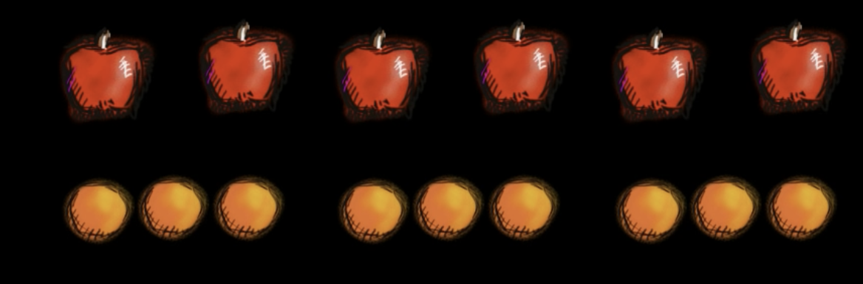

6 Apples
9 Oranges
The ratio of apples to oranges is 6 to 9 or 6:9.
You can also read it as how many apples to we have to a certain amount of oranges?
If you divide 3 between 6 and 9 the answer is 2 and 3.
So the answer is, for ever 2 apples, there is 3 oranges.

Intro to rates:
https://youtu.be/qGTYSAeLTOE
Usually when people are talking about rates, they are comparing what is happening per a unit of time.
Example: 35MPH
The rate is 35 miles per every hour if the speed is consistent.

Example: $10 per hour
The rate is $10 per every hour worked.

Intro to Precents:
Shade 20% of the square below:
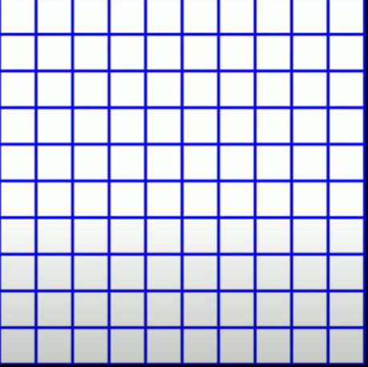
= 20 per cent
= 20 per 100
The whole cube is 100%.
- There is 100 squares within the cube, so you would need to shade 20 of the squares to share 20% of the entire cube.
- Each square is 1% of the 100% cube.

